QUICK GUIDE SERIES FM 2014-1

Spruc-
e Beetle

An Agent of Suba1pine Change
The spruce beetle is a native species in Colorado's spruce forest ecosystem. Endemic populations are always present, and epidemics are a natural
part of the changing forest. There usually are long intervals between such events as insect and disease epidemics and wildfires, giving spruce forests time to regenerate. Prior to their occurrence, the potential impacts of these natural disturbances can be reduced through proactive forest management.
The spruce beetle (Dendroctonus rufipennis ) is responsible for the death of more spruce trees in North America than any other natural agent.
Spruce beetle populations range from Alaska and Newfoundland to as far south as Arizona and New Mexico. The subalpine Engelmann spruce is the primary host tree, but the beetles will infest any
spruce tree species within their geographical range, including blue spruce. In Colorado, the beetles are most commonly observed in high-elevation spruce forests above 9,000 feet.
At endemic or low population levels, spruce beetles generally infest only downed trees. However, as spruce beetle population levels in downed trees increase, usually following an avalanche or windthrow event - a high-wind event that topples trees over a large area - the beetles also will infest live standing trees.
Spruce beetles prefer large (16 inches in diameter or greater), mature and over­ mature spruce trees in slow-growing, spruce-dominated stands. However, at
epidemic levels, or when large-scale, rapid population increases occur, spruce beetles may attack trees as small as 3 inches in diameter. Attacks also have been observed in
laummholz - trees near timberline that exhibit stunted growth due to harsh conditions.
L ife Hitory
Spruce beetles have a life cycle of one to three years, and a two-year life cycle is the most

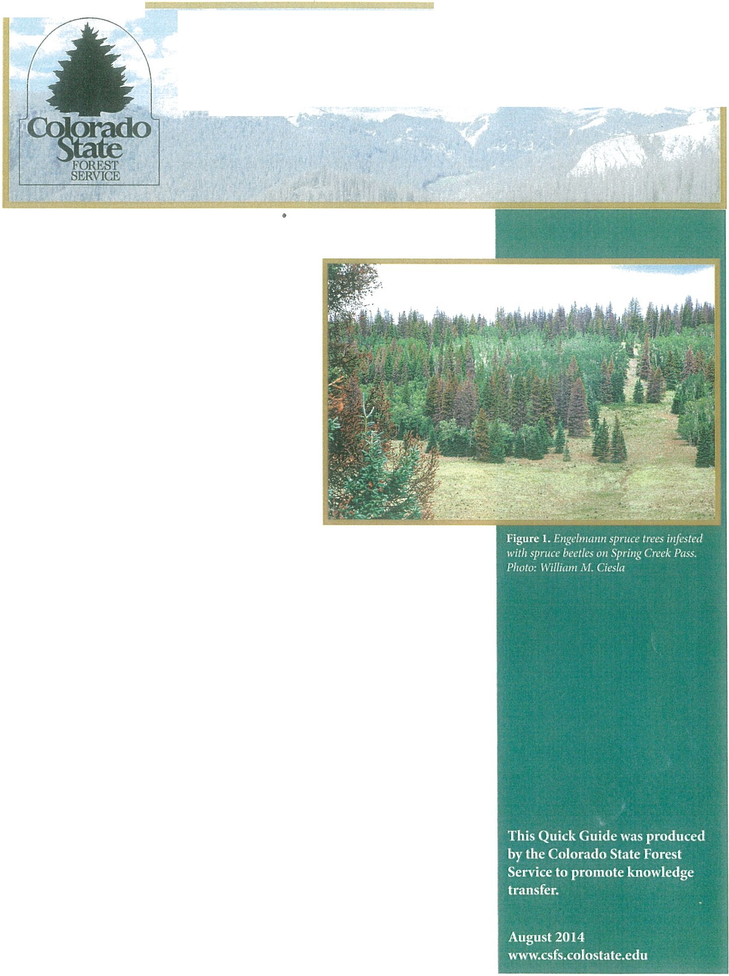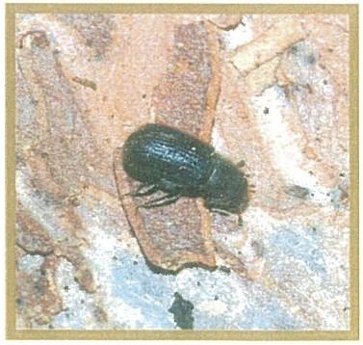Figure 2. Spruce beetles are no larger than a grain of rice. Photo: William
- Ciesla
common. Adult spruce beetles usually are dark brown to black with reddish-brown or black wing covers. They are cylindrical in shape and

\\ inh'r
approximately 14-inch (6 millimeters) long and Vs-inch (3 millimeters) wide, or about the size of a grain of rice.
Each year, adult spruce beetles emerge from dead or dying trees between late May and July. Emerging beetles search for sufficient host material, such as a windthrow; freshly cut logs or stumps; or mature, standing trees. The females bore through the outer bark of the host tree to create galleries in
the sapwood, or phloem, where they will lay their eggs. Spruce beetle eggs are minute, oblong in shape and pearly white in color.
After the eggs hatch, the spruce beetle larvae spend the winter developing under the bark of their host trees. The larvae are creamy white and about %-inch (6 millimeters) long. They tunnel outward, away from the egg gallery, creating individual feeding galleries, or tunnels, in the phloem of the tree. The

phloem layer, which transports nutrients created from photosynthesis throughout the tree, also provides food for the larvae. However, the feeding galleries created by the larvae prevent the flow of nutrients, ultimately killing the tree.
The larvae turn into pupae approximately 18 months after the host tree is attacked. Spruce beetle pupae, like mature adults, have wings, legs and antennae, and turn a pale tan color as they mature.

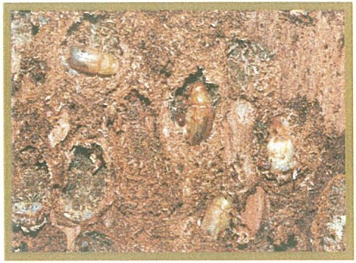
Figure 4. Spruce beetles in the pupal stage reside under the bark . Photo: William M. Ciesla

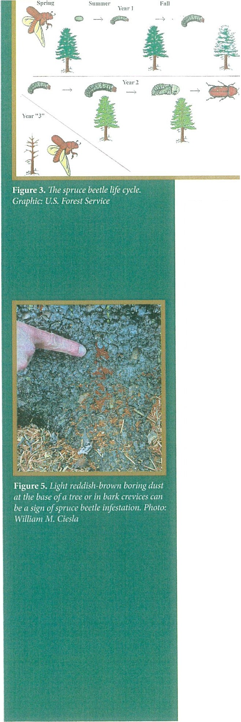During the second year of the spruce beetle life cycle, some beetles spend the winter in pupal chambers at the end of larval galleries, while others emerge from their host tree and bore back into the same tree near the base to hibernate for the winter. Overwintering at the litter line, or base of the host tree, decreases the risk of predation by woodpeckers and the risk of beetle mortality due to cold winter temperatures, as accumulating snowpack adds an insulating layer around the lower trunk of the host tree. After the beetles have developed for 2 years, they will exit the host tree and look for a new host.
Signs and Symptoms of Spruce Beetle Infestation
Unlike some other dying and dead conifers infested by bark beetles, needles of infested spruce trees do not turn bright red or orange. Instead, after being
attacked by spruce beetles, spruce needles slowly fade to a pale yellowish-green color before turning gray. Spruce trees often retain their needles for several years after being attacked by spruce beetle. Thus, loss of foliage is not readily apparent until a year or more after a tree has been attacked.
After a tree has been infested by spruce beetles, early signs of attack may include:
  - Light reddish-brown boring dust accumulates in bark crevices and arotmd the base of the tree, which is produced when beetles bore new entry holes.

2

- 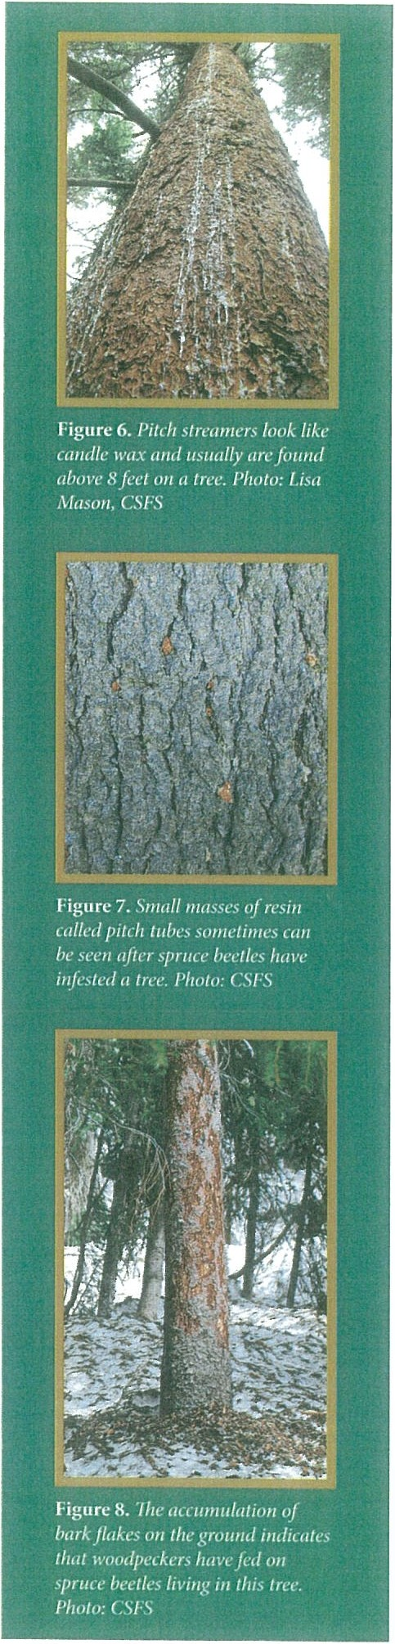Pitch streamers - strings of resin that look similar to candle wax - generally visible 8 feet or higher on the tree trunk.
- Small pitch tubes, or masses of resin, although these may not be present on an infested tree.
These signs of infestation are most visible during the summer of initial attack and become less visible in the following seasons. Other signs of attack that may be observed later include:
- Small, round holes in the bark of an infested tree. These holes usually are a result of mature beetles exiting the tree after they have completed their development under the bark, but they also may indicate spruce beetle entrance and/or ventilation holes.
- Evidence of increased woodpecker activity. Woodpeckers will attempt to remove tree bark to prey on the underlying bark beetles, usually in the winter and spring, which often results in the accumulation of bark flakes on the snow or grotmd below the infested tree.
- Pale green needles. As they begin to drop, these needles also will accumulate under the canopies of infested trees.
Spruce beetle attacks also can be detected on the bottom surfaces of downed, windthrown trees or shady surfaces on trees, usually on the north side. For further assistance in identifying spruce trees attacked by spruce beetle, contact your local forester.

Natural Controls
Multiple natural controls keep spruce beetle populations in check when they are not at epidemic levels. Woodpeckers and other insects that feed on spruce
beetles account for several of these controls.During epidemics, however, natural control agents, while abundant, do not have a significant impact on the beetle population. Extreme cold temperatures also can increase spruce beetle mortality. However, adult beetles will colonize around the base of a tree, or under the snow line, because the snow will insulate them from extreme cold.

Management/Prevention
One of the best ways to mitigate the effects of spruce beetle outbreaks is to manage for overall forest health and resiliency. Improving tree stand condition, by creating tree age and species diversity, will maintain and support forest health and reduce the potential impact of future spruce beetle attacks. Removing downed spruce also may prevent the build-up of large local spruce beetle populations.
When considering any treatment for spruce beetles, choose an option that best meets individual management objectives. Treatments can be effective if directions are carefully followed, but can be time-consuming and costly, and may not be practical or effective for all situations. Also, it is important to note
that spruce forests usually are present only at higher elevations, where access to sites is limited and may be restricted by snow.It is essential to research the best possible treatments for a specific area before taking action.

3

n, ,·, .,:, . fll ....
Use of insecticides is a management technique that has proven effective in preventing spruce beetle infestation of individual trees. Certain formulations of carbaryl and pyrethroids that are registered and have been tested for effectiveness are the primary insecticide sprays used to help reduce the likelihood of attacks on individual, high-value trees. The Colorado State Forest Service (CSFS) recommends spraying only high-value trees, such as those
near homes, businesses or recreation sites. Overuse of insecticide sprays may have negative environmental impacts on water supplies and wildlife. Also, these sprays are not cost-effective on a landscape scale.
Before using preventive chemical sprays, consider the following guidelines: Insecticide sprays may be effective if applied to live, green trees:
  - in the late spring or early summer, before the next year's flight
  - in the fall, before the next year's flight, if access to the site is difficult in the early spring
  - in the proper dosage and mixture
  - annually
  - consistently, to cover the entire tree Insecticide sprays will NOT be effective if:
  - applied to trees already infested with spruce beetles
  - applied in improper dosages or mixtures
  - significant rainfall or very high air temperatures occur immediately after application
  - chemicals were not properly stored before use
If planning to use preventive sprays, carefully read all label precautions before application. The CSFS recommends that preventive sprays be applied only by a certified applicator.
\olar Treatmeuts
Solar treatments also can be used to reduce spruce beetle populations in infested stands. These treatments involve felling infested trees and stacking logs in an area with full sun before covering them with clear plastic. Solar treatment of infested trees creates conditions unsuitable for survival of spruce beetles, forcing them to either relocate or die. The temperature under the bark must reach a minimum
of 110 degrees F for this treatment to effectively reduce beetle populations. Remember that spruce beetles tend to reside on the bottom side of horizontal trees or logs, where the environment is cooler and moister. Turning the logs periodically is essential for all of the bark to reach 110 degrees F. Solar treatments in spruce forests can be challenging, because spruce forests tend to be cool, moist and shady, without ample sunlight. Talk to your local CSFS forester to determine if this is an appropriate treatment for your area.

l t 11f> 11'"" '
Trap trees are another management option that can prevent the spread of spruce beetle populations. These trees serve as traps for emerging, adult spruce beetles. Trap trees are intentionally baited with a spruce beetle attractant chemical that ideally will be selected as suitable hosts for emerging spruce beetles. After the

4

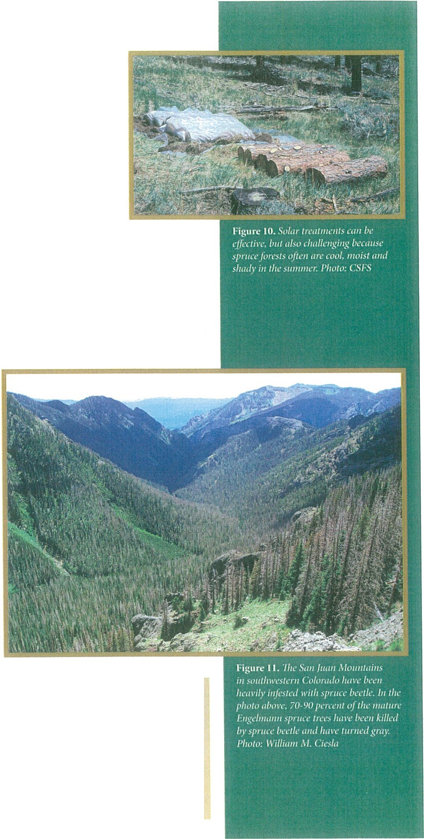trap trees become infested with beetles, they are removed and destroyed by forest managers while all of the spruce beetles are still inside, thereby reducing the population level of the next generation.This method is
effective, but requires a significant amount of time and effort to plan, monitor and safely remove trees in a timely manner. Many variables must be considered, including the number of trap trees per acre, tree diameter and timing for tree cutting and removal. It is highly recommended that a local CSFS forester be contacted before using this treatment option.

PllL /"OlllO I Z.!S
Studies currently are being conducted on pheromones, including MCH (a successful anti-aggregate pheromone for Douglas-fir beetle), to determine whether they will serve as effective anti-aggregate treatments for spruce beetle. Anti­ aggregate pheromones essentially are "No Vacancy" signs that
communicate to beetles that specific trees are unavailable to more beetles. The CSFS will make information available on pheromone effectiveness as soon as sufficient research on its use has been conducted.
iW.echanical Treatments
Mechanical treatments, such as felling trees and subsequently chipping the wood and/or burning the resulting slash piles, is another management option, but it often is difficult to get the proper
equipment on steep, remote terrain where spruce forests exist. Debarking is another mechanical means to kill developing larvae under the tree bark. This is a labor-intensive method that involves peeling away the bark by hand or using machinery.Logs also can be buried under at least 8 inches of soil. However, debarking and burying logs often are not feasible options in native spruce forests because of the terrain.
Contact a local CSFS forester for more information on best forest management practices to improve forest health and mitigate spruce beetle outbreaks.

It is important to remember that transporting infested wood can spread spruce beetles to other areas. Trees and logs are only safe to transport when a tree has lost all
of its needles or has been dead for some time and the spruce beetles have long-since enzerged .

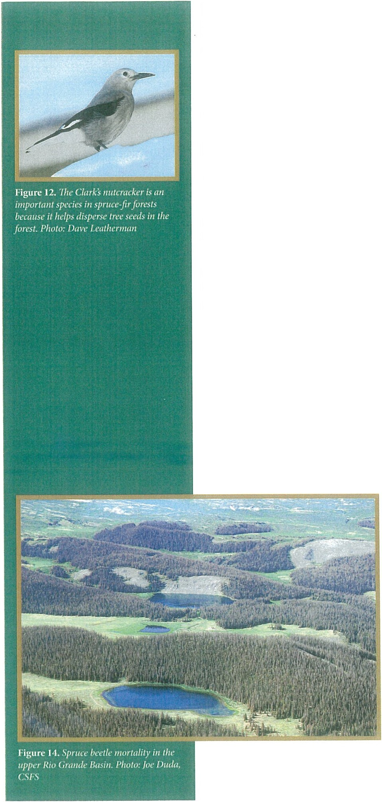Potential Implications of Spruce Beetle iP Color1do
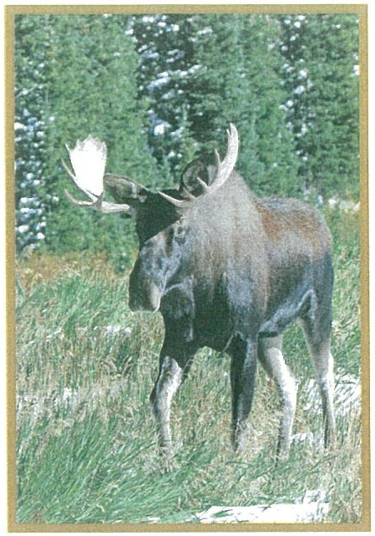Colorado's high-elevation forests provide clean air and water, wildlife habitat, world-class recreational opportunities, wood products and unparalleled scenery. These benefits contribute to quality of life and are vital to state and local economies. However, without careful
management of forest resources, these assets and community safety are at risk.
It is important to remember that the spruce beetle is a native insect in Colorado's spruce forest ecosystem and a natural part of the changing forest.
However, the potential impacts of these natural disturbances can be reduced through proactive forest management.
Forests typically attacked and killed by spruce beetles are located at the headwaters of Colorado's rivers, which
provide water to 18 states. Water yields may be influenced by the death of so many trees, and the impacts to water quality and quantity may be significant when large wildfires occur in these
forests. Figure 13. Spruce -fir forests provide habitat
for many wildlife species. Photo: Dave
Spruce-fir forests provide important Leatherman
habitat to a number of wildlife species, including the red squirrel, snowshoe hare, pine marten, boreal owl, Clark's nutcracker and three-toed woodpecker. Spruce­ fir forests also are essential to the habitat matrix required by the reintroduced Canada lynx and one of Colorado's most at-risk amphibians, the boreal toad, which inhabits open, high-moisture areas within spruce-fir forests. Seventeen
of Colorado's "Species of Greatest Conservation Need;' as identified by Colorado Parks and Wildlife, rely on spruce-fir forests for their primary habitat. Change in forest cover of spruce-fir forests could negatively impact the habitat of these species.
Recreational opportunities, such as downhill and cross-country skiing, camping, hunting and fishing, also are predominant in areas of the state that could be impacted by the spruce beetle.
It is critical to proactively manage spruce forests and for individuals and communities to remain informed about
threats to forest health to ensure survival of vast, healthy forests for present and future generations.

Wildfire Safety in Spruce-fir Forests
·when addressing spruce beetle concerns in high ­ elevation forests, it is i mportant to understand historical wildfire occurrence in spruce forests. Unlike many other Colorado forest types, spruce-fir forests are not adapted to frequent fi res. The interval between naturally occurring wildfi res in Colorado spruce-fir forests may be 300 years or longer. Ifa wildfire does occur in a spruce forest, the trees' thin bark and the persistence of many dead lower limbs increases their susceptibility to fire, as well as the likelihood of intense crown fires and widespread tree mortality.If a stand-replacing fire occurs in a spruce-fir
forest where most or all of the trees in the stand are killed,
it may take as long as 400 years for the forest to mature.

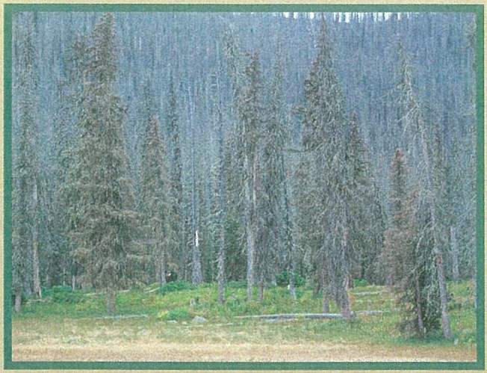
Figure 15.Spruce beetle mortality ca11 contribute to high wildfire risk. Photo: Kent Grant, CSFS

\Nhen treating spruce-fir forests to mitigate wildfi re risk, concentrate on reducing fuel loads. Heavier fuels, such as brush and trees, are more hazardous and produce more intense fires than light fuels, such as grasses. Fuels mitigation focuses on breaking up the continuity of fuels, with greater distance between trees and other vegetation.
When managing spruce-fir forests for wildfire hazard reduction around homes or other structures, consider the following:
- Remove dead and downed debris on the ground to break up the continuity of flammable material. This can help slow the spread of a wildfire. Leave rotting wood on the ground.
- Prune off the dead lower branches of any spruce tree within 100 feet of the home or structure. This will reduce the likelihood of a wildfire traveling up the tree.
- Remove all dead trees within one-and-a- half times the tree height around homes, structures or roads. Not only are they a wildfire hazard, they also are more apt to fall.
- 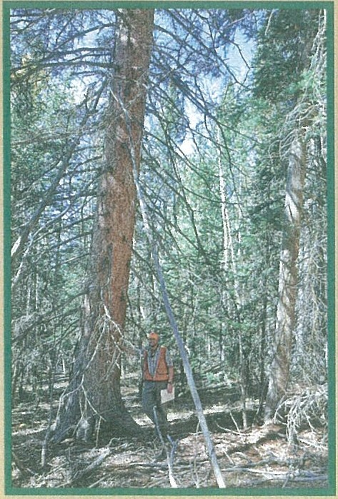Spruce forests are susceptible to windthrow and thinning them can increase this risk. Before thinning spruce forests or designing a defensible space around a home or stmcture, it is advisable to talk with a forester.
For more i nformation on reducing wildfire risk on your property, refer to the CSFS website at http://csfs.colostate.edu.

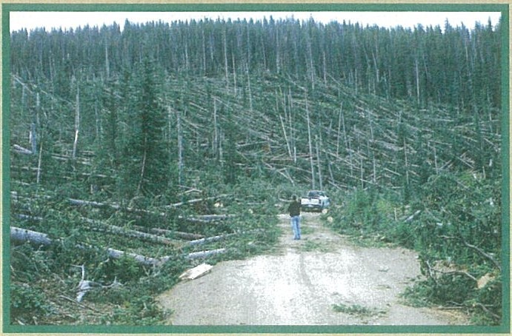

Figure 16. Blowdown areas i11 spruceforests can increase the contimtit} offlmnmable mt1terial during a wildfire. Photo: Rio Grande
.'ic1tiont1/ Forest
Figure 17. Prun111g the lower bmnches of a spruce tree can reduce the clumces of a wildfire traveling up ,1 tree. Photo: CSFS

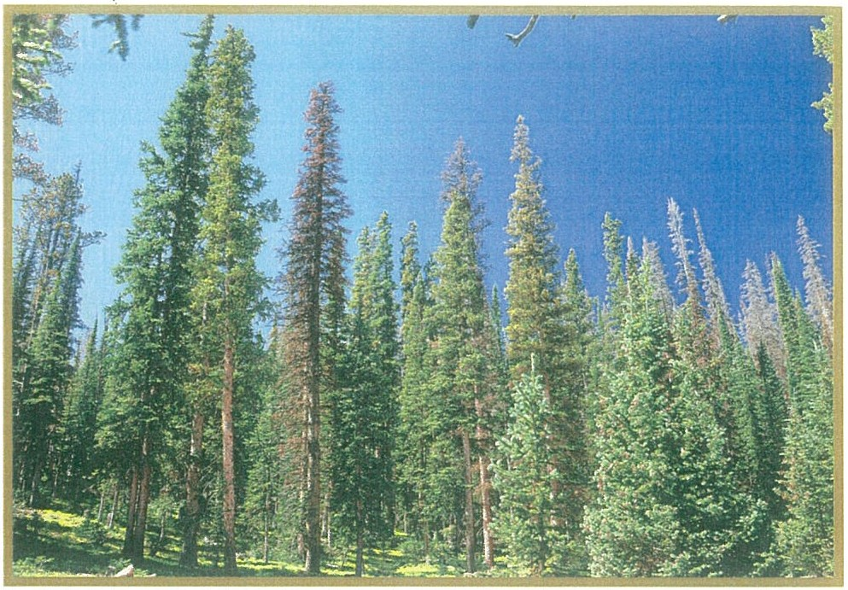
Figure 18. Colorado'sspruce-firforests provide clean air and water, wildlife habitat, world-class recreational opportunities, wood products and unparalleled scene1y. Photo: William M.Ciesla

For More Information
For more information on spruce beetles or forest management, contact a local Colorado State Forest Service district office or visit the CSFS website at www.csfs.colostate.edu.

References
Colorado Statewide Forest Resource Assessment: A foundation for strategic discussion and implementation of forest management in Colorado. 2008. Colorado State Forest Service.
Field Guide to Diseases and Insects of the Rocky Mountain Region. 2010. United States Department of Agriculture Forest Service, Rocky Mountain
Region.
Holsten E. H., Thier R. W, Munson A. S., and Gibson K. E. 1999. "The Spruce Beetle:' Forest Insect and Disease Leaflet 127. U. S. Department of Agriculture Forest Service.

Note: The "Species of Greatest Conservation Need" referred to in this Quick Guide were identified by Colorado Parks and Wildlife aspart of Colorado's State
Wildlife Action Plan, available online at: http://wildlife.state. co.us!WildlifeSpecies/ ColoradoWildlifeActionPlan/ePagoes/Colorado WildlifeActionPlan.aspx.
SERVICE
w1··1 .( sf,., ,lost 11 ,ii.
The Colorado State Forest Service (CSFS) is a service and outreach agency of the Warner College of Natural Resources at Colorado State University.
11.is Quick Guide was produced by the CSFS. CSFS programs are available to all without discrimination. No endorsement of products or sen,ices is intended, nor is criticism implied of products not mentioned.
08201410000

